# FDD

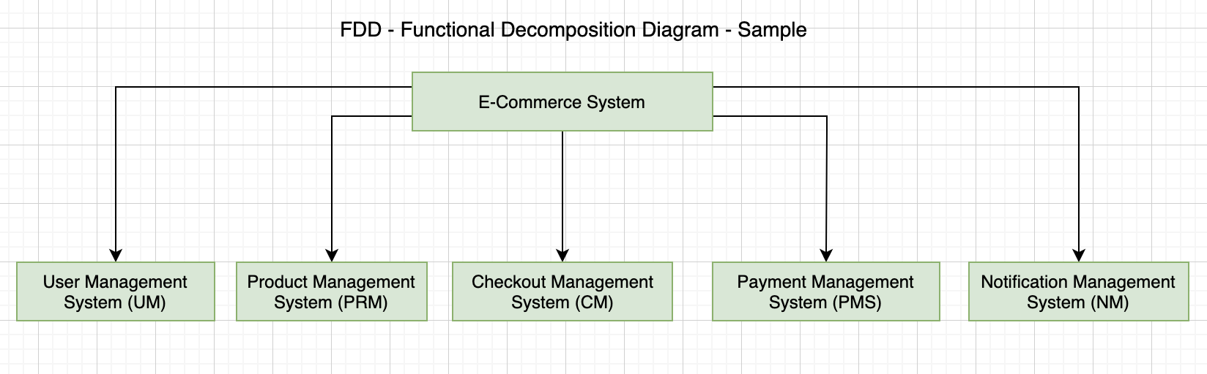

# Legend



# Product Management System (PRM)

|  |  |  |
| --- | --- | --- |
| **Req. Code** | **Req. Desc** | **Use Case** |
| PRM-F-1.0 | The system should allow the admin and product manager to create the product. [create product] | Create product |
| PRM-NF-1.1 | When creating a product, the minimum resolution of product image to be uploaded should be of a minimum 1024 X 760 while not exceeding 10mb of file size. [size related things, performance related, security related, and any other technical things] |  |
| PRM-NF-1.2 | The SKU of the product must be unique and the SKU itself should represent the color, size and style number. Example: TS-111-BLU-XL, which may represent a t-shirt (TS) having style number 111 in blue (BLU) color of Extra-Large Size (XL) |  |
| PRM-UR-1.1 | The uploading of image should support drag and drop for the easy upload. |  |
| PRM-UR-1.2 | ….  …. |  |
| PRM-F-2.0 | The system should allow the product manager to create product categories with short description [create product category] |  |
| PRF-NF-2.1 | Description of the categories must not exceed more than 100 words |  |
| PRF-UR-2.1 | …. |  |

# User Management System (UM)

|  |  |
| --- | --- |
| **Req. Code** | **Req. Desc** |
| UM-F-1.0 | The system should allow the customer for self-registration. It should support Social registration too (Google, Facebook and twitter social register) [register user] |
| UM-NF-1.1 | While submitting the registration form, the registration data must be encrypted before sending over to server. (security) |
| UM-NF-1.2 | The password for the registration must be a combination of alphabets, numbers and special characters. |
| UM-UR-1.1 | While registering via smaller devices (mobile devices), the password field should have an option to hide/unhide password |
| UM-UR-1.2 | ….  …. |
| UM-F-2.0 | The admin should be able to ban/unban the user [ban/unban user] |
| UM-NF-2.1 | …. |
| UM-UR-2.1 | …. |

Note:

1. This is all part of the Agile approach that we have discussed earlier
2. You should only focus on SRS of a particular sub system at a time
3. Once SRS is completed, it’s better to draw activity diagram
   1. Now the question might be “how many activity diagrams do we need to draw?”
      1. There is no hard and fast rule for this answer. Normally you will be drawing activity diagram as per the number of your functional requirements. If there are 8 functional requirements of a sub-system, generally there will be 8 activity diagrams
   2. After activity diagram, its better to draw use case diagram then wireframe then ERD then Data Dictionary then Class Diagram then Sequence diagram and others….
4. Some common questions:
   1. How many use-case diagrams?
      1. If you have 4 sub-systems, there will be use case diagrams
   2. How many use cases should be there in each use case diagram?
      1. If you have identified 10 functional Requirements for a particular sub system. Then there will be 10 use cases in that use case diagram
   3. How many sequence Diagram?
      1. Normally it would depend on the number of functional requirements you have
   4. How many entities in ERD?
      1. Need all the entities as per the system requires
   5. How many classes in class diagram?
      1. Need all the classes as per the system requires
   6. How many wireframes?
      1. Normally it would depend on the number of functional requirements you have